**Homework 1 Solutions**

# Problem 1

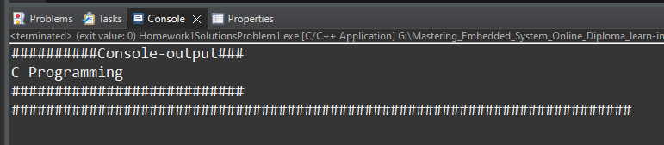Write C Program to Print a Sentence I should see the Console as following:

* **Solution**

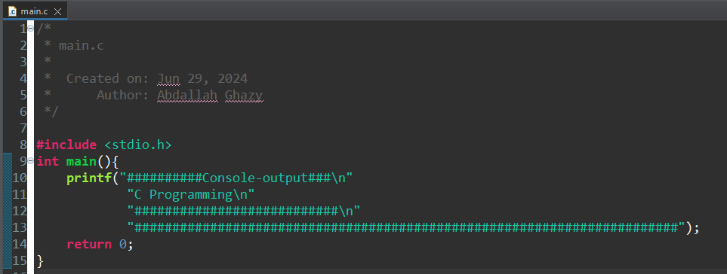

# Problem 2

Write C Program to Print a Integer Entered by a User I should see the Console as following:

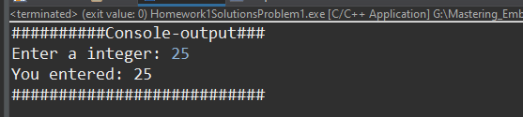

* 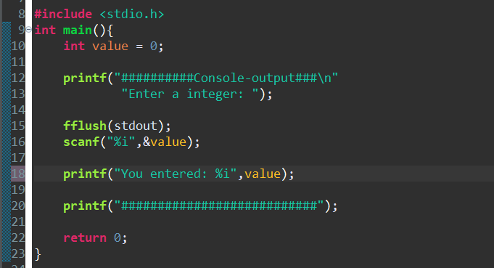**Solution**

# Problem 3

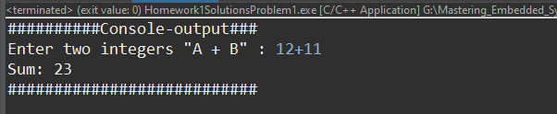Write C Program to Add Two Integers I should see the Console as following:

* **Solution**

**#include** <stdio.h>

**int** **main**(){

**int** num1 = 0;

**int** num2 = 0;

**printf**("##########Console-output###\n"

"Enter two integers \"A + B\" : ");

**fflush**(stdout);

**scanf**("%i + %i",&num1,&num2);

**printf**("Sum: %i\n",num1+num2);

**printf**("###########################");

**return** 0;

}

# Problem 4

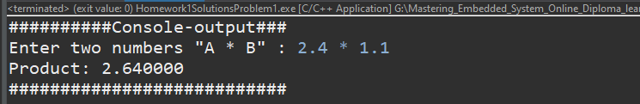Write C Program to Multiply two Floating Point Numbers I should see the Console as following:

* **Solution**

**#include** <stdio.h>

**int** **main**(){

**float** num1 = 0;

**float** num2 = 0;

**printf**("##########Console-output###\n"

"Enter two numbers \"A * B\" : ");

**fflush**(stdout);

**scanf**("%f * %f",&num1,&num2);

**printf**("Product: %f\n",num1*num2);

**printf**("###########################");

**return** 0;

}

# Problem 5

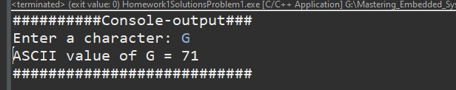Write C Program to Find ASCII Value of a Character

* **Solution**

**#include** <stdio.h>

**int** **main**(){

**char** character;

**printf**("##########Console-output###\n"

"Enter a character: ");

**fflush**(stdout);

**scanf**("%c",&character);

**printf**("ASCII value of G = %d\n",character);

**printf**("###########################");

**return** 0;

}

# Problem 6

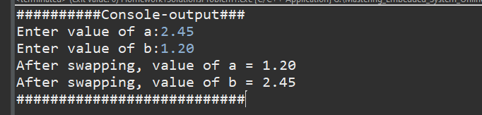Write Source Code to Swap Two Numbers

* **Solution**

**#include** <stdio.h>

**int** **main**(){

**float** a = 0;

**float** b = 0;

**float** x = 0;

**printf**("##########Console-output###\n");

**printf**("Enter value of a:");

**fflush**(stdout);

**scanf**("%f",&a);

**printf**("Enter value of b:");

**fflush**(stdout);

**scanf**("%f",&b);

x = a;

a = b;

b = x;

**printf**("After swapping, value of a = %.2f\n",a);

**printf**("After swapping, value of b = %.2f\n",b);

**printf**("###########################");

**return** 0; }

# Problem 5

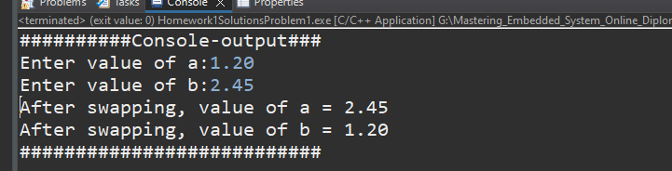it is an interview trick, Write Source Code to Swap Two Numbers without temp variable.

**#include** <stdio.h>

**int** **main**(){

**float** a = 0;

**float** b = 0;

**printf**("##########Console-output###\n");

**printf**("Enter value of a:");

**fflush**(stdout);

**scanf**("%f",&a);

**printf**("Enter value of b:");

**fflush**(stdout);

**scanf**("%f",&b);

a += b;

b = a - b;

a = a - b;

**printf**("After swapping, value of a = %.2f\n",a);

**printf**("After swapping, value of b = %.2f\n",b);

**printf**("###########################");

**return** 0;

}

يتميز هذ الحل بقدرته علي التبديل بين الأرقام العشرية ولا يشكل وجود فصلة عشرية أي مشكلة

حل اخر باستخدام XOR مشكلة هذا الحل انه لا يتعامل مع الأرقام العشرية

**#include** <stdio.h>

**int** **main**(){

**int** a = 0;

**int** b = 0;

**printf**("##########Console-output###\n");

**printf**("Enter value of a:");

**fflush**(stdout);

**scanf**("%i",&a);

**printf**("Enter value of b:");

**fflush**(stdout);

**scanf**("%i",&b);

a = a ^ b;

b = a ^ b;

a = a ^ b;

**printf**("After swapping, value of a = %i\n",a);

**printf**("After swapping, value of b = %i\n",b);

**printf**("###########################");

**return** 0;

}